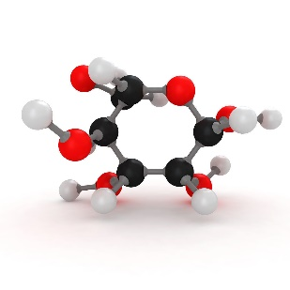**Empirical and Molecular Formulas**

The **empirical formula** is the smallest whole-number ratio of the elements in a compound.

The **molecular formula** is the number of each element in a molecule.

**Examples**

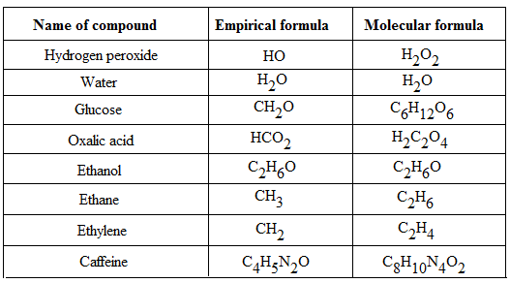

Tip:

The formula for ionic and covalent network compounds is always given as the simplest ratio (empirical formula) as they do not form molecules.

**Calculating the Empirical Formula of a Compound**

1. Determine the mass of each element (if not given)
2. Calculate the number of moles of each element
3. Determine the simplest whole number ratio of each element
4. Write the formula by applying the ratio

**Example 1a**

A compound contains 50.05 % sulfur and 49.95 % oxygen by weight. The molecular weight of the compound is 64.07 g/mol. What is its molecular formula?

**Solution:**

1) Assume 100 g of the compound is present. This changes the values to grams:

mass(S) = 50.05 g

mass(O) = 49.95 g

2) Convert the masses to moles:

moles (S) = 50.05 g / 32.066 = 1.5608 mol

moles (O) = 49.95 g / 16.00 = 3.1212 mol

3) Divide by the lowest, seeking the smallest whole-number ratio:

S = 1.5608 / 1.5608 = 1

O = 3.1212 / 1.5608 = 2

S:O = 1:2

NB If this ratio is not a whole number ratio, multiply both sides by the number required to produce whole numbers

4) Write the empirical formula: SO2

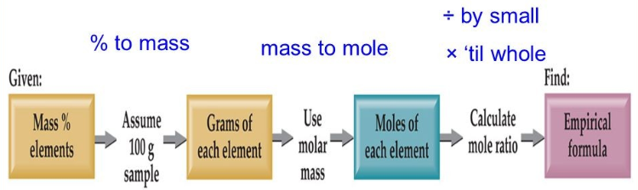

**Calculating the Molecular Formula from an Empirical Formula**

1. Calculate the empirical formula (if required)
2. Determine the empirical formula mass
3. Determine the number of formula units in the molecular formula (divide the molecular formula mass by the empirical formula mass).
4. If required, rewrite the formula.

**Example 1b**

The compound's molecular weight in problem 1 is 64.07 g/mol. What is its molecular formula?

1. The empirical formula is SO2 (from 1)
2. Empirical formula mass

M(SO2) = 32.06 + 16.00 + 16.00 = 64.06

1. Number of empirical formula units

Number of formula units = 64.07 / 64.06 = 1.0002 = 1

1. Therefore, the molecular formula mass is SO2

**Try these problems:**

**Problem 2:** A compound contains 64.80 % carbon, 13.62 % hydrogen, and 21.58 % oxygen by weight. What is the empirical formula for this compound? The molecular weight of this compound is 74.14 g/mol. What is its molecular formula?

**Problem 3:** A compound contains 31.42 % sulfur, 31.35 % oxygen, and 37.23 % fluorine by weight. What is the empirical formula for this compound? The molecular weight of this compound is 102.2 g/mol. What is its molecular formula?

**Problem 4:** A molecule with a molecular weight of 180.18 g/mol is analysed and found to contain 40.00% carbon, 6.72% hydrogen and 53.28% oxygen. What are the empirical and molecular formulas of the molecule?

